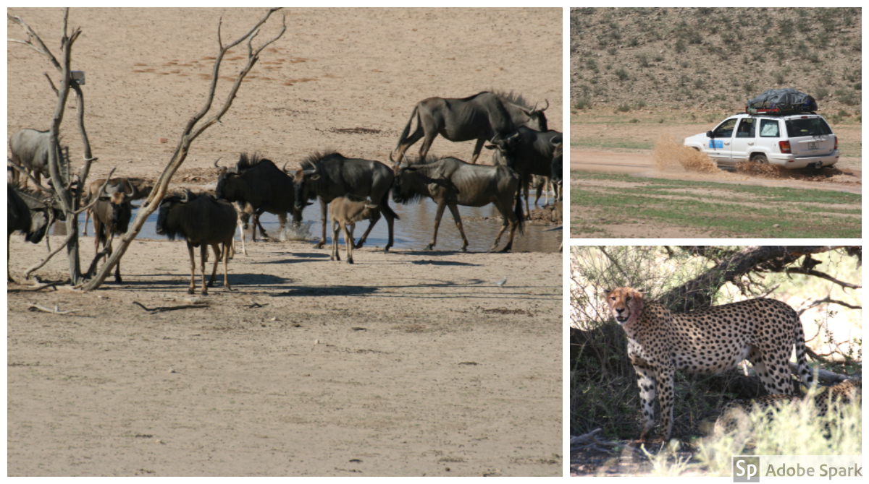
What would I do without you guys I have just got back from a rekey trip to the Kalahari desert wilderness To find new locations for our next trip for our clients in Feb 2019. The first evening I was about 140 KS into the desert when we had a storm the likes I have not seen; we had about 350-mil (12 inches) of rain in one night. This is unheard of in this arid part of South Africa and Botswana the photos below, were taken 2 days after the rains. See how green the desert is and you will see we use a Jeep on this trip. We had no other vehicle with us and we saw no other people for 3 days. This trip would not have been possible without my old satphone, that I bought from you all some years ago. I take it everywhere with me when traveling in the bush; it just makes me feel safer to know I can contact outside help if needed. I hope one day you or your friends and family might see this stunning country. Thanks again for all you do for me and my company. Speak soon John

