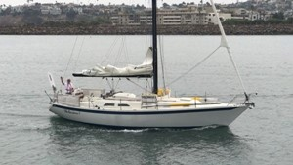

Christian Williams

“I used your Iridium 9555 on my solo sail 5,000 miles to Hawaii and back this summer. Never dropped a call, and the fixed mast antenna you also rented me was a big success. I sent a position email every day, with a KML file that showed my position on Google Earth. Thanks for the personal service!”

You can shorten as you like.

The phone appears in my video ( https://www.youtube.com/watch?v=z5m9yT06Khg ) at minute 28:55 .

Cheers,
Christian Williams
Thelonious II

